CODES/OUTPUT

**SCREEN SHOTS OF CODES.OUTPUT**

|  |  |  |
| --- | --- | --- |
| **Supervisor.** | Sir Shakir Khan | |
| **Batch.** | 2305E1 | |
| **Group.** | 02 | |
| **Serial No.** | **Enrollment No.** | **Student Name** |
| 1. | Student1478236 | Atta Muhummad |
| 2. | Student1478241 | Hassan ullah |
| 3. | Student1477700 | Aniqa |
|  |  |  |

**Navbar code: (html code) :-**

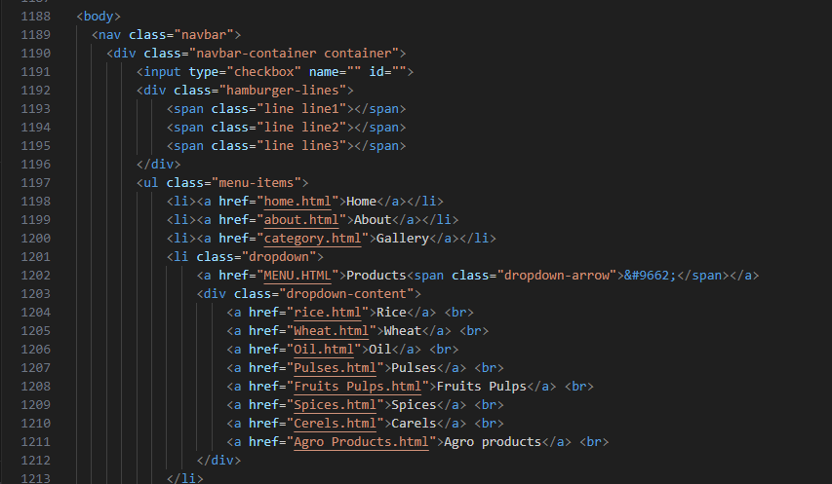

**CSS Code**:

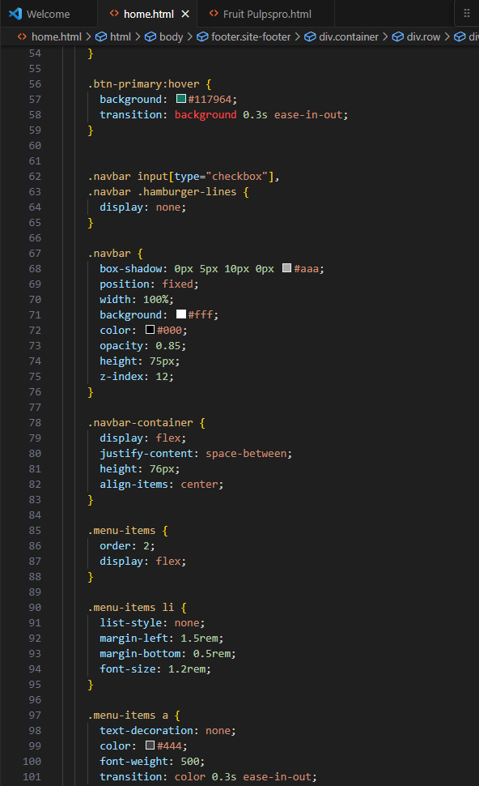

**OUTPUT:**



**Footer code (Html):**

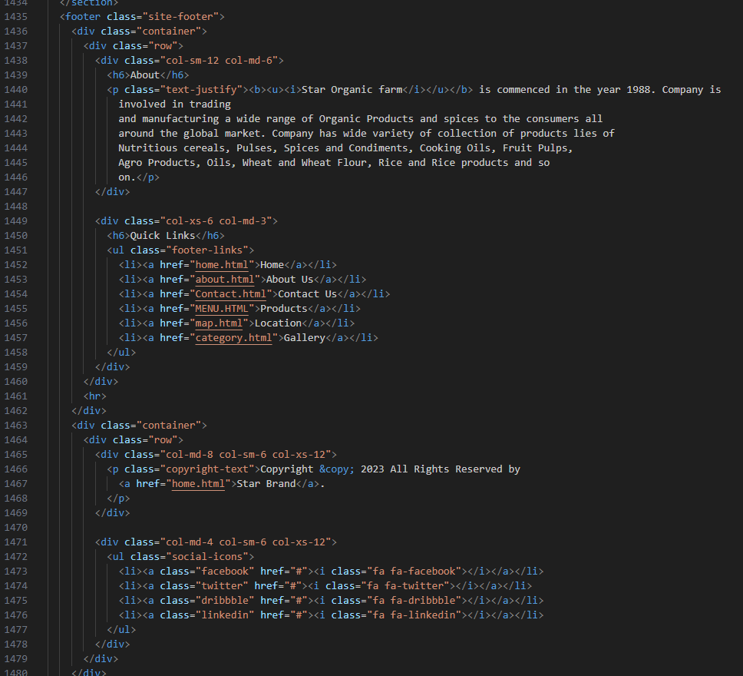

**CSS Code:**

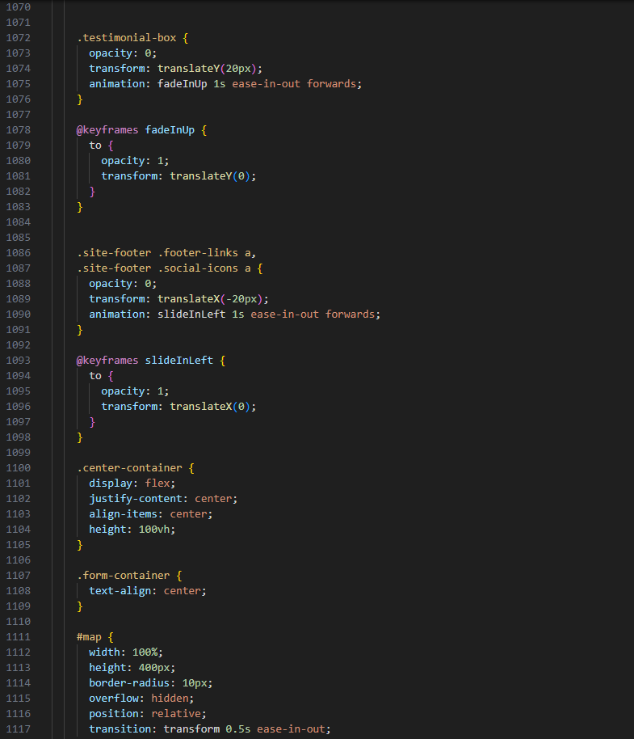

**OUTPUT:**

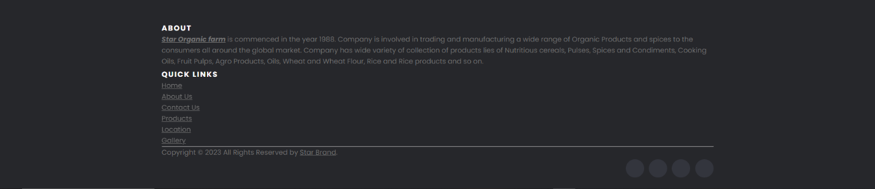

MENU Code(html):

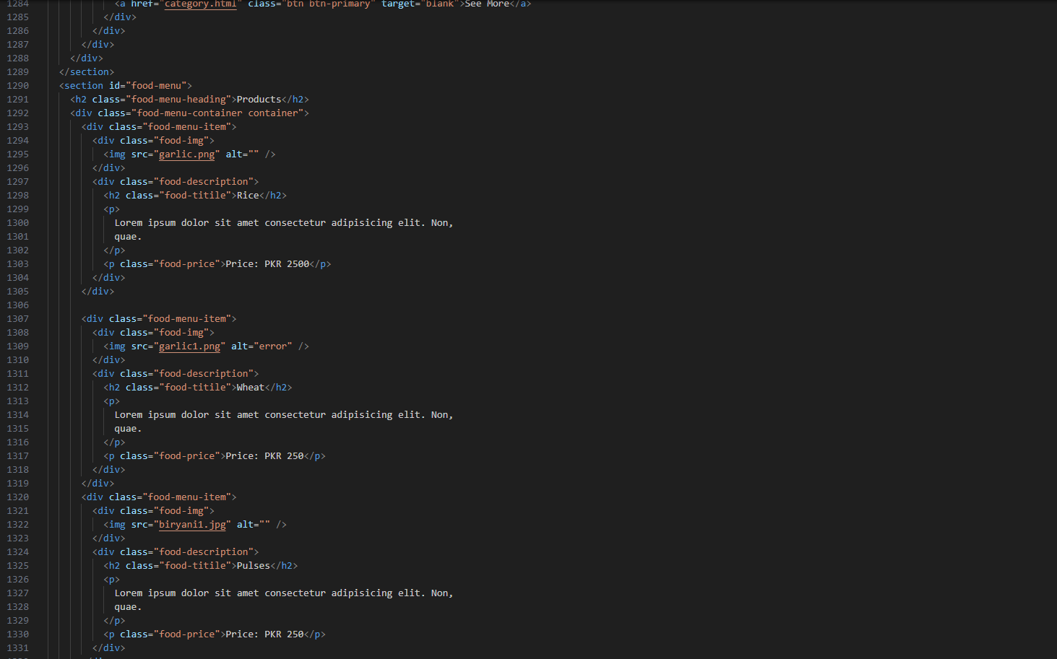

**CSS Code:**

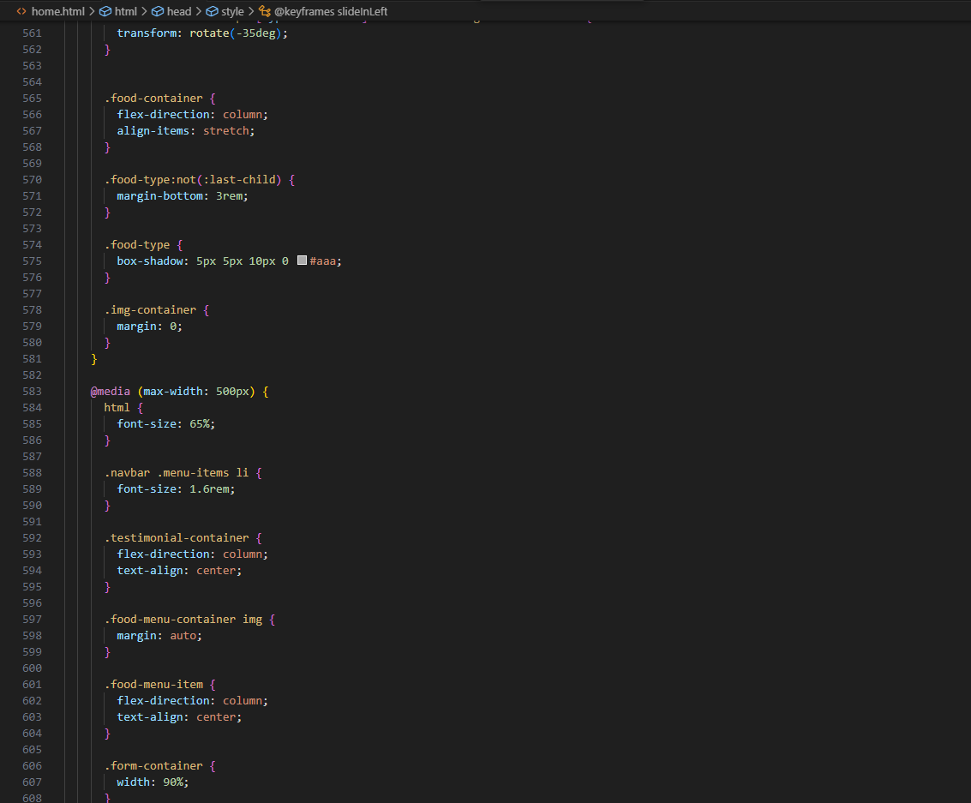

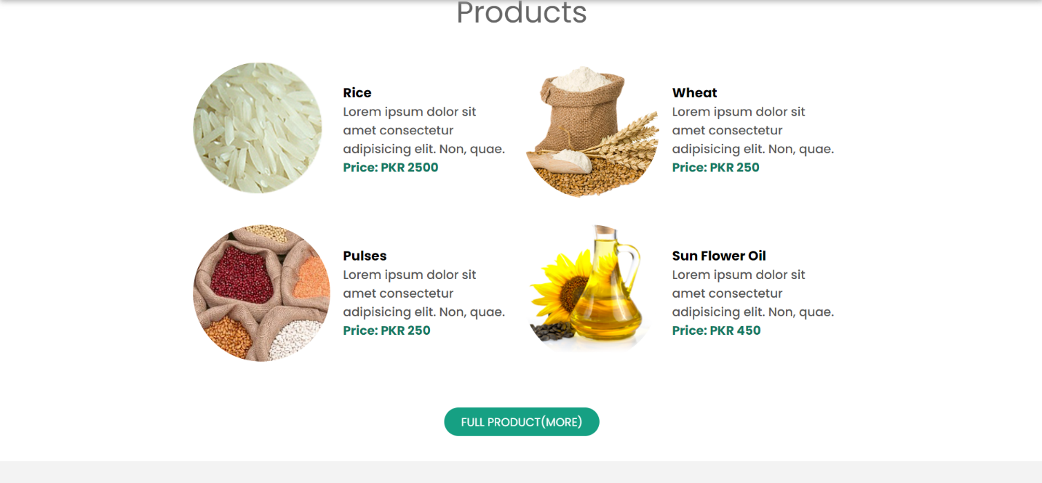

**OUTPUT:**



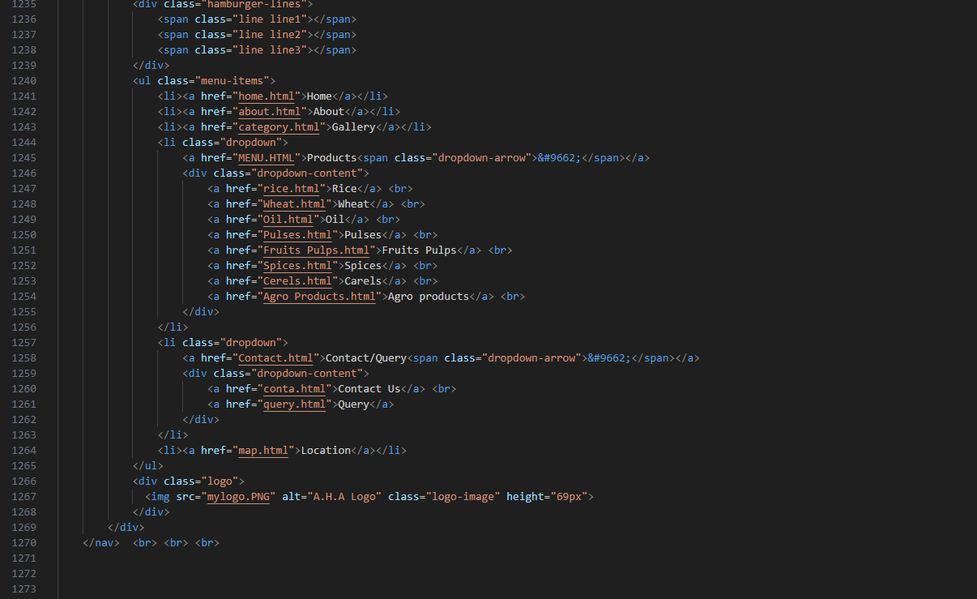MAP Code(html):

**CSS Code:**

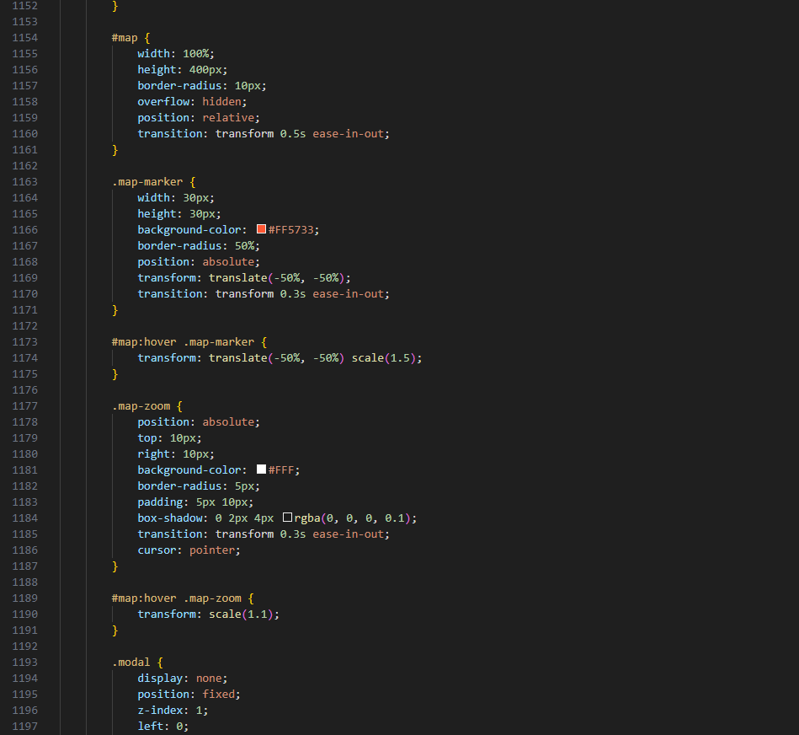

**OUTPUT:**

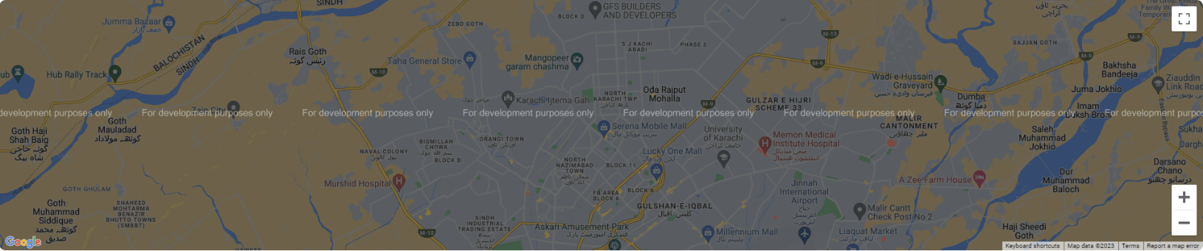

CONTACT Code(html):

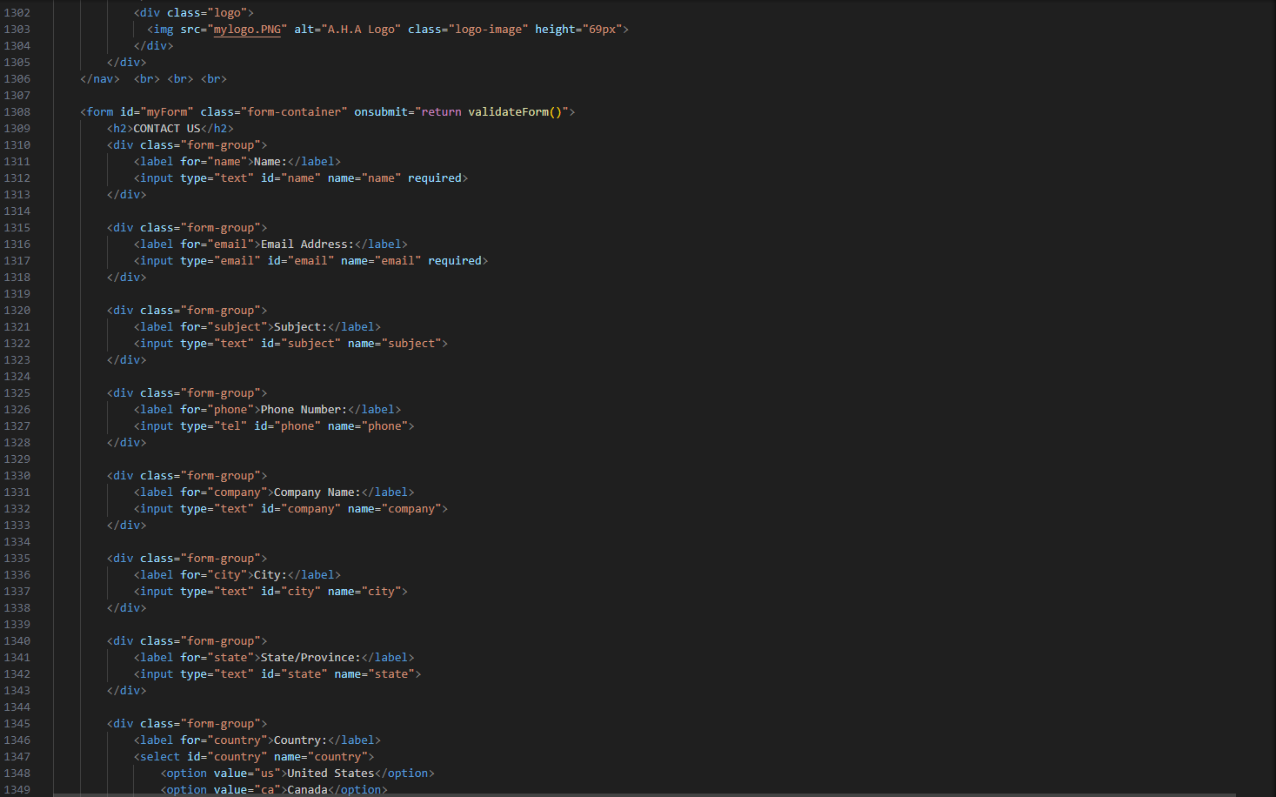

**CSS Code:**

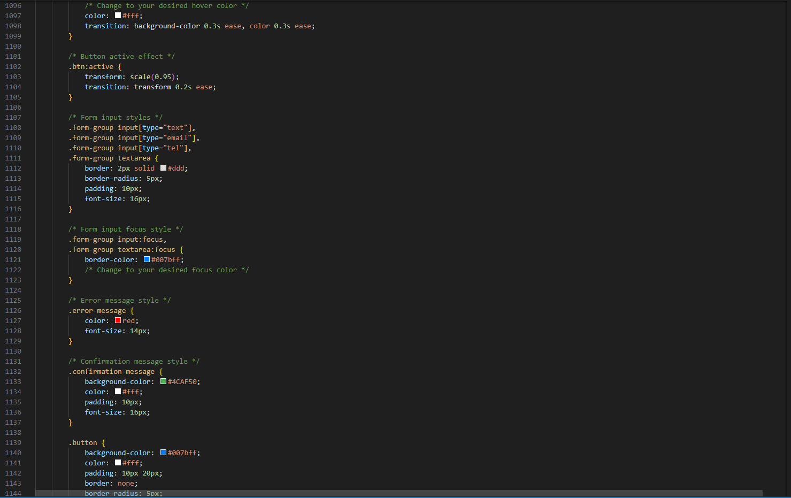

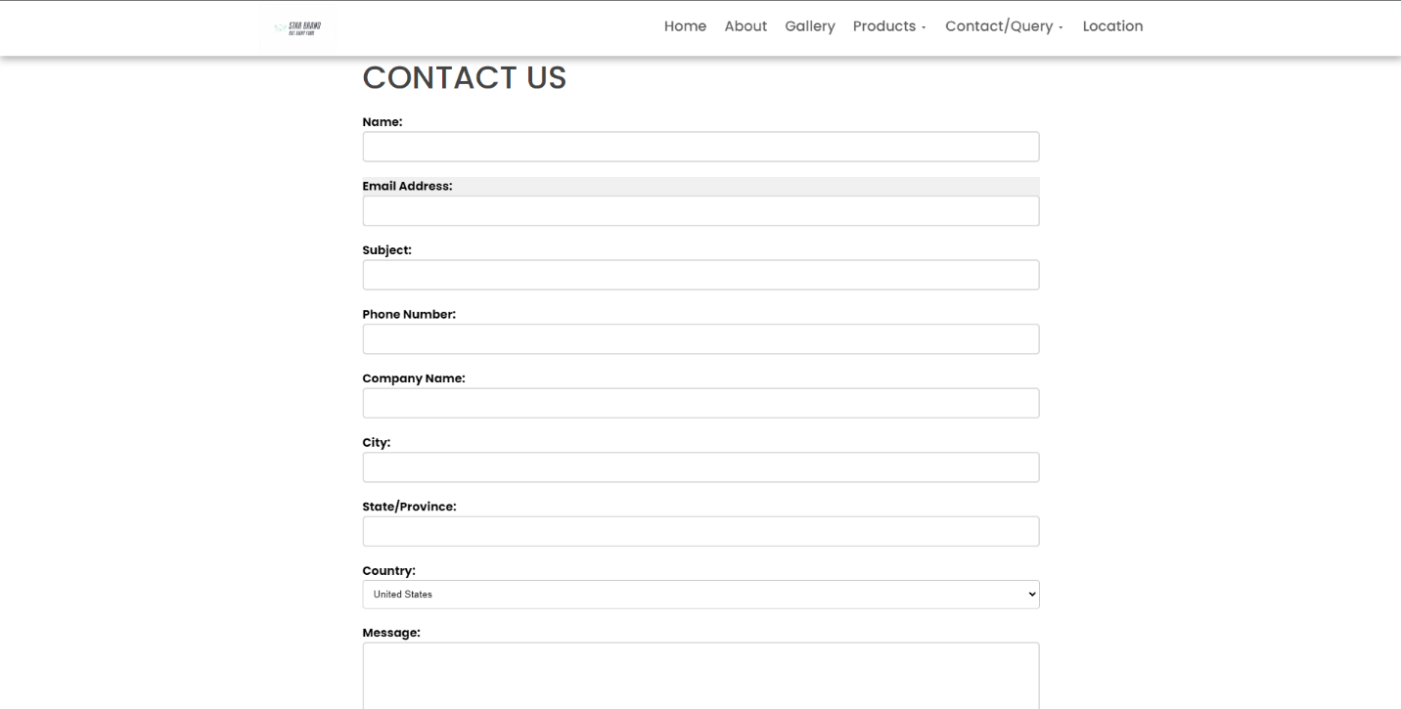**OUTPUT:**

***Thank You For Reading The Documentation.***

***Please Follow The Instructions Above !!***